1. Write a C program to find length of a string.

**Sample:**



1. Write a C program to copy one string to another string.

**Sample:**

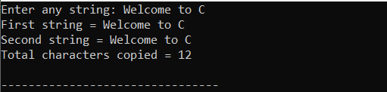

1. Write a C program to concatenate two strings.

**Sample:**

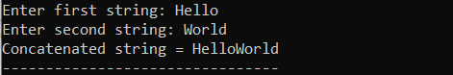

1. Write a C program to compare two strings.

**Sample:**

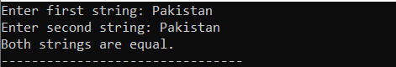

1. Write a C program to convert lowercase string to uppercase.

**Sample:**



1. Write a C program to convert uppercase string to lowercase.

**Sample:**

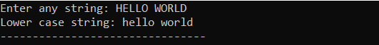

1. Write a C program to toggle case of each character of a string.

**Sample:**

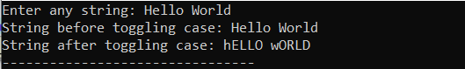

1. Write a C program to find total number of alphabets, digits or special character in a string.

**Sample:**

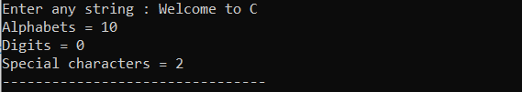

1. Write a C program to count total number of vowels and consonants in a string.

**Sample:**

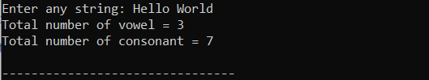

1. Write a C program to count total number of words in a string.

**Sample:**



1. Write a C program to find reverse of a string.

**Sample:**

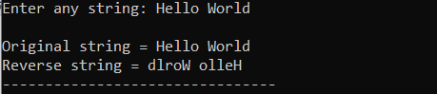

1. Write a C program to check whether a string is palindrome or not.

**Sample:**



1. Write a C program to reverse order of words in a given string.

**Sample:**

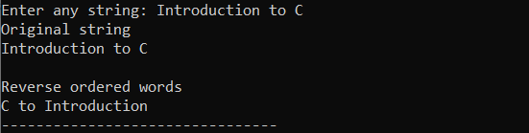

Q1.Write a program that extracts part of the given string from the specified position. For example, if the sting is "Working with strings is fun", then if from position 4, 4 characters are to be extracted then the program should return string as "king". If the number of characters to be extracted is 0 then the program should extract entire string from the specified position.

Q2.Write a program that converts a string like "124" to an integer 124.

Q3.A Credit Card number is usually a 16-digit number. A valid Credit Card number would satisfy a rule explained below with the help of a dummy Credit Card number—4567 1234 5678 9129. Start with the rightmost - 1 digit and multiply every other digit by 2. 4 5 6 7 1 2 3 4 5 6 7 8 9 1 2 9 8 12 2 6 10 14 18 4 Then subtract 9 from any number larger than 10. Thus we get: 8 3 2 6 1 5 9 4 Add them all up to get 38. Add all the other digits to get 42. Sum of 38 and 42 is 80. Since 80 is divisible by 10, the Credit Card number is valid. Write a program that receives a Credit Card number and checks using the above rule whether the Credit Card number is valid.

Q4.Write a program to add two 3 x 3 matrices.

Q5.A 3 x 3 matrix is entered through the keyboard. Write a program to obtain the Determinant value of this matrix.

Q6.The area of a triangle can be computed by the sine law when 2 sides of the triangle and the angle between them are known. Area = (1 / 2 ) ab sin ( angle ) Given the following 6 triangular pieces of land, write a program to find their area and determine which is largest.

Q7.Write a program to obtain transpose of a 4 x 4 matrix. The transpose of a matrix is obtained by exchanging the elements of each row with the elements of the corresponding column.

Q8.Write a program to pick up the largest number from any 5 row by 5 column matrix.

Q9.Write a program which performs the following tasks: Initialize an integer array of 10 elements in main( ) Pass the entire array to a function modify( ) In modify( ) multiply each element of array by 3 Return the control to main( ) and print the new array elements in main( )

Q10. If an array arr contains n elements, then write a program to check if arr[ 0 ] = arr[ n-1 ], arr[ 1 ] = arr[ n - 2 ] and so on.

1. Write a program that find largest element in an array using recursion in c.
2. Write a structure to store the roll no., name, age (between 11 to 14) and address of students (more than 10). Store the information of the students.

1 - Write a function to print the names of all the students having age 14.

2 - Write another function to print the names of all the students having even roll no.

1. Write a program that takes string from user and print it in reverse using recursion in c.
2. Create a transcript as per the following requirements.

Name: ______________ Semester: _______

Reg No: ____________ Subject: ________

|  |  |  |  |  |  |
| --- | --- | --- | --- | --- | --- |
| Quiz | Assignment | Mid Term | Final | Total Marks | Obtained Marks |
|  |  |  |  |  |  |
| GPA:_____________ | | | | | |

1. Using array of structures to get the transcript for each student.
2. The GPA calculation should be as per CUI rules.
3. Enter some students’ data.
4. Student result can be searched.

Q1. Write a program to store and print the roll no., name , age and marks of a student using structures.

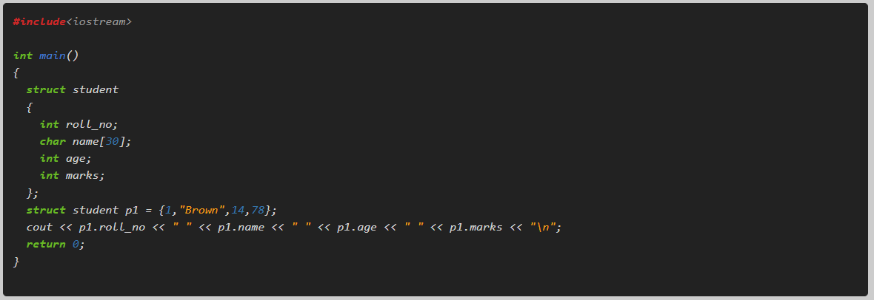

1. Q2.  Create a structure to specify data on students given below:  
   Roll number, Name, Department, Course, Year of joining Assume that there are not more than 450 students in the college.  
   (1) Write a function to print names of all students who joined in particular year.  
   (2) Write a function to print the data of a student whose roll number is received by the function.
2. Q3.  Enter the marks of 5 students in Chemistry, Mathematics and Physics (each out of 100) using a structure named Marks having elements roll no., name, chem_marks, maths_marks and phy_marks and then display the percentage of each student.
3. Q4.  Write a structure to store the name, account number and balance of customers (more than 10) and store their information.  
   1 - Write a function to print the names of all the customers having balance less than $200.  
   2 - Write a function to add $100 in the balance of all the customers having more than $1000 in their balance and then print the incremented value of their balance.
4. Q5.  Write a structure to store the roll no., name, age (between 11 to 14) and address of students (more than 10). Store the information of the students.  
   1 - Write a function to print the names of all the students having age 14.  
   2 - Write another function to print the names of all the students having even roll no.
5. Q6.  Write a program to compare two dates entered by user. Make a structure named Date to store the elements day, month and year to store the dates. If the dates are equal, display "Dates are equal" otherwise display "Dates are not equal".
6. Q7.  Create a structure called library to hold accession number, title of the book, author name, price of the book, and flag indicating whether book is issued or not. Write a menu-driven program that implements the working of a library. The menu options should be:  
   1. Add book information

2. Display book information  
3. List all books of given author  
4. List the title of specified book  
5. List the count of books in the library  
6. List the books in the order of accession number 7. Exit

